STEPS FOR DETERMINING SOILS CLASSIFICATION:

1. Visually inspect spoil pile and trench for indication of cohesive or granular soils. If soil appears to be cohesive, conduct plasticity test. If soils are cohesive classify soils by either thumb penetration, shear vane, or pocket penetrometer. If soils do not pass plasticity test, classify granular soils by sedimentation test. NOTE: Other visual and manual tests are authorized in appendix A to 29 CFR 1926- Subpart "P".

2. Determine if soil is cohesive (plasticity test). The following provides a couple of examples for cohesive soil testing:

A. Roll or Thread test: Mold a moist or wet sample of soil into a ball and attempt to roll it into threads as thin as 1/8" in diameter. Cohesive material can be successfully rolled into threads without crumbling. For example, if at least a two inch length of 1/8" in diameter thread can be held on one end without tearing the soil is cohesive.

NOTE: Only use material passing a No.40 sieve.

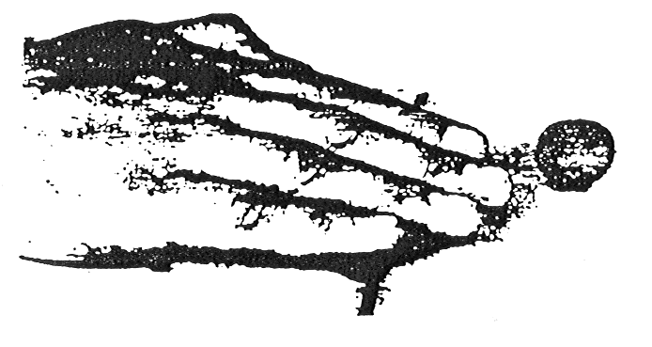
ROLL OR THREAD TEST

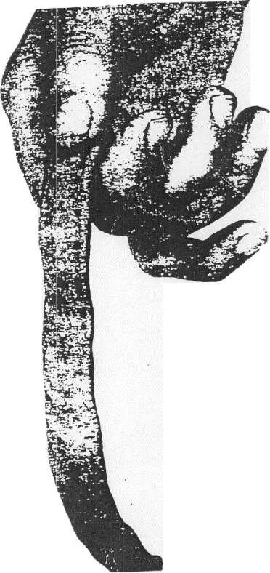
B. Ribbon Test: Form a roll of moist soil about 1/2" to 3/4" in diameter. Cohesive material can be successfully rolled into 1/2" to 3/4" ribbon without crumbling. For example, if at least 3" to 5" in length can be held on one end without tearing the soil is cohesive.

NOTE : Only use material passing a No. 40 sieve.

3. If plasticity test(s) proves that soils have cohesive qualities, determine the type of soil (A,B,C by using the following test methods:

NOTE: Soil testing equipment shall be used in accordance with manufactures specifications.

A. Thumb penetration (cohesive soils only):
Type "A": 1/4" or less
Type "B": 1/4" to 1"
Type "C": 1" or more
Figure 1 - Ribbon Test
B. Determining Shear Strength (cohesive soils only): By using a hand held vane shear device, the soil condition for cohesive soils can be determined. The following provides an example of the application of the vane shear:

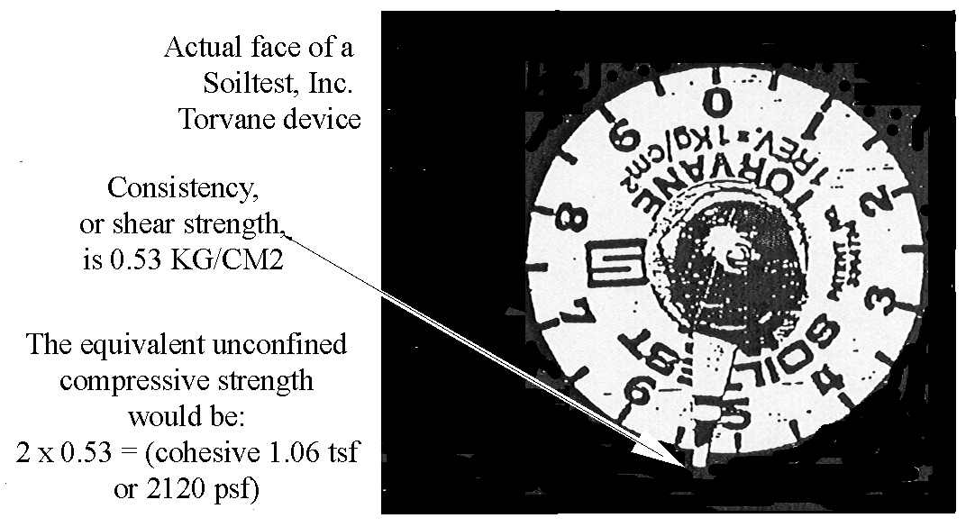

NOTE: This example illustrates a Type "B" soil condition.

C. Determining unconfined compressive strength (cohesive soils only): By using a hand held pocket penetrometer, the soil condition for cohesive soils can be determined. The following provides an example of the application of the pocket penetrometer:

PHOTOGRAPH OF A SOILTEST, INC. POCKET PENETROMETER:

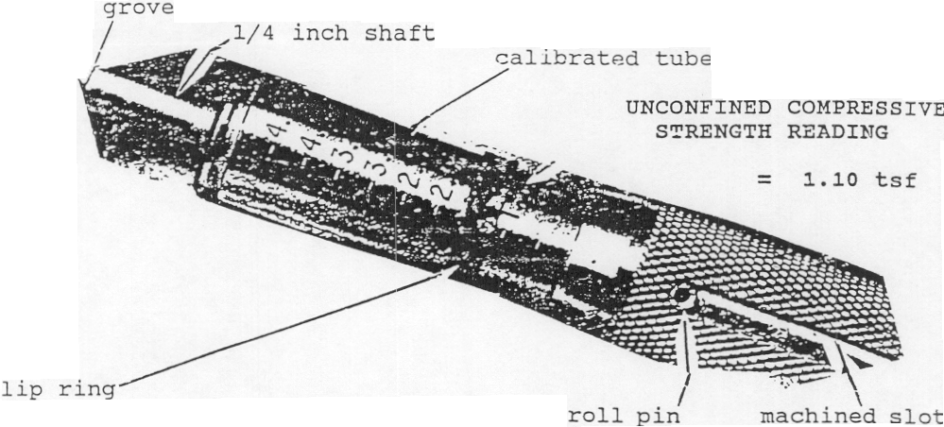

NOTE: Pocket penetrometer is only pushed into the soil until the grove line on the 1/4" shaft penetrates the soil.

4. If soil does not have cohesive qualities (granular soils), use the sedimentation test to determine if soils are a type "B" or "C" soil.

SEDIMENTATION TEST

A. The Sedimentation Test is the hydrometer analysis adapted for field use. Larger particles are the first to settle out of a soil-water suspension. It is used to determine the amount of sand in a sample taken in the field and is used only on soils that are obviously sands or very sandy. To run the sedimentation test, a representative sample of the soil is taken from the spoil pile. Great care must be taken to insure that the sample represents the soil in the trench or excavation; otherwise the test will not be accurate.

B. The soil sample, after the gravel is removed, needs to be large enough to fill a glass jar to a depth of approximately 1-1/2". The soil is placed in a tall straight-sided glass jar so that there is at least 5" of water on top of the soil. The jar should have a flat bottom and must be at least 61/2" inches tall (olive jars work well) .

C. The gravel may be removed by spreading a representative sample of the soil on a flat surface and hand picking the gravel, or by using a number 10 sieve or a piece of 1/8" hardware cloth. The 1/8" hardware cloth will pass some of the smaller gravel particles; they will need to be hand picked. All cohesive aggregations must be broken up so that all particles fall as individuals in the soil water suspension. Use clean water for the test. Place the lid on the jar and thoroughly shake the mixture. After the particles have been completely dispersed and the suspension is uniform, set the jar down and give it slight twist. The larger particles will begin to settle out immediately. The twist levels out the largest particles so that a level surface is generated. All of the sand will have settled out 30 seconds after you set the jar down. Make a mark on the side of the jar. File folder labels work well for marking because they stick well to a damp jar.

D. The particles will continue to settle out of the suspension until nearly clear water remains above the layered soil. Most of the silt will have settled out in an hour. Make a second mark. Seldom is it necessary to wait over an hour. This test is good only for those soils that have a very high percentage of sands. The soil must be thoroughly dispersed because any small clods of silt and clay remaining unbroken up will act like sand.

E. All soil material below the first mark is sand. The material between the lines is silt and most of the clay. Allowing for the thickness of the glass jar bottom, determine the total height of the soil and the height of the sand. Divide the height of the sand by the total height of the soil and multiply by 100; the result will be the percentage of sand in the sample.

F. If the silt-clay mixture settles out rather quickly, mostly silt is indicated. If the suspended solids above the sand settle out slowly, mostly clay is indicated.

G. Recall that if silt is the primary fine material present, the soil can be called a loamy sand, even though it has only 70% sand by this test. If clay is the primary fine material, there must be 85% sand to call the material a loamy sand.

